Tab 1




AI-assisted Online Shopping for Luxury Products
Feasibility Report

Prepared by:

Jalal
Hetal
Zhengqun

Executive Summary
This document provides a Feasibility Report for implementing an artificial intelligence (AI) inside an online luxury shop that is designed to enhance customer experience through assisted personalization, seamless omnichannel integration, and exceptionally fast service.
After a period of exceptional growth, the global luxury industry is facing a significant slowdown, with growth forecast at a slower 1% to 3% annually between 2024 and 2027 (The State of AI in Luxury: 2026 Industry Benchmark, DLG x Europa Star). Executives report a predominant sentiment of "uncertainty" (The State of Fashion 2024, BoF & McKinsey & Company).
56% of luxury clients are dissatisfied with their current shopping experience, and they hold heightened service expectations, often comparing luxury service against seamless digital experiences in other sectors (2025 Luxury CX and AI Global Survey, BCG). It not only decreases the brand status, but also forms a profit decline for the company. AI's importance has grown over the years and can help customers make purchasing decisions.
55% of luxury firms are currently in the early stages (Exploring or Experimenting), with a large cluster (42%) reportedly "trapped in experimentation bottlenecks." (The State of AI in Luxury: 2026 Industry Benchmark, DLG x Europa Star).
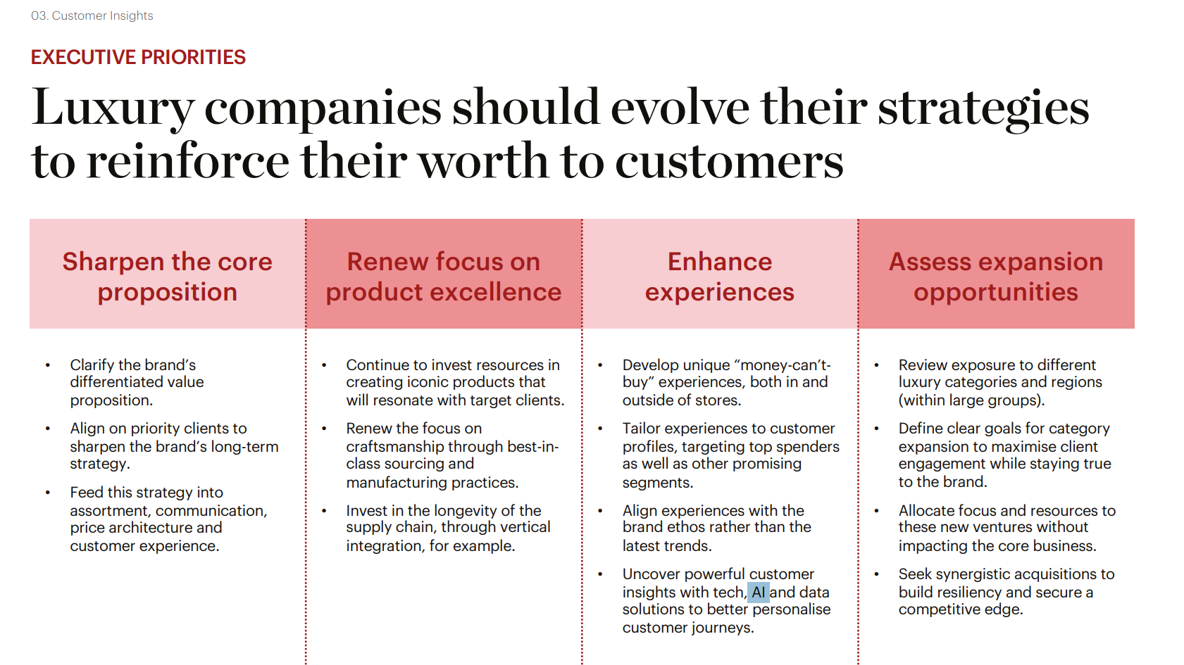
The main idea behind this feasibility report is to implement a solution that:

- Provides unique personalization with amicable interactions and assistance by AI.
- Enables seamless integration between physical and virtual digital store shopping experience for convenient online payment.
- Provides vastly faster online shopping speeds compared to competitors.
This report indicates the business, technical and financial feasibility of using digital solutions to enhance customer’s experience with tools like highly adaptable AI, scalable secure wireless transactions and account management with encrypted keys stored in a database.
The goal is to maintain strong customer loyalty through an always-available online service while maintaining the human touch, which will reduce brand risk in the virtual shopping world.
Background and Problem Statement
Despite the growth of artificial intelligence (AI) and digital shopping, the current digital shopping journey lacks the exclusivity and reliability expected by high-value customers. A company may face issues in establishing a brand identity if they are not transparent about the use of AI to elevate their customer service.
Strategic Area | AI Opportunity | Impact
Customer Engagement | Scale White-Glove Service: AI enables the extension of hyper-personalized service from ultra-high income VIPs to a broader client segment, enhancing the human touch. | Clients find AI most helpful in the research phase (63%) and post-purchase support (40%).
Advisor Enhancement | "Superhuman" Client Advisors: AI provides real-time client insights, and purchase history. AI can also draft personalized communication for advisors to send to their clients. | Improves advisors' ability to recall details for a large and growing client base.
Online Experience | Enhanced Item Discovery: AI-powered virtual advisors and intuitive search tools guide clients online with the same expertise as a human advisor. | 38% of clients report shopping more online for luxury now than they did 3-5 years ago.
Creative & Design | AI is prioritized for its potential to augment human creatives in design and product development workflows. | 73% of fashion executives prioritize Gen AI for 2024.

Problem to Solution Mapping
This section details the core technical components and architecture necessary to build the AI-assisted online luxury shopping platform. We will leverage Microsoft Azure's robust, scalable, and secure services.
The Problem
AI-assisted online luxury retail faces fundamental challenges in delivering a premium, seamless shopping experience across both online and physical channels. Luxury brands must therefore undertake a strategic reset with AI and data capabilities as a core part of the new customer engagement strategy.
Technical Feasibility and Service Model Justification
Problem Category | Key Solution(s) & Justification
Omnichannel Friction & Experience Gap | Azure AI Search | Unifies customer data for seamless transitions.
Omnichannel Friction & Experience Gap | Azure App Service | Hosts centralized platform for service continuity across online and offline.
Inconsistent Stock and Listing Accuracy | Azure SQL Database | Stores a single source of truth for inventory data. High availability ensures real-time accuracy.
Dilution of Luxury Brand Identity in E-commerce | Azure OpenAI Services | Delivers human-like white-glove conversational service.
Dilution of Luxury Brand Identity in E-commerce | Azure AI Search | Provides personalized recommendations.
Non-transparent Use of Artificial Intelligence | Azure OpenAI Services | This provides the mitigation that AI dialogue is transparently labeled as AI assistance.
Web Server Overload Risk | Azure App Service | Built-in horizontal auto-scaling handles peak traffic. Prevents server overload.
Data Security & Customer Authentication | Azure AD B2C | Provides secure customer auth (SSO/MFA).
Data Security & Customer Authentication | Azure Key Vault | Manages secrets/encryption keys.
Data Security & Customer Authentication | Azure SQL DB | Provides TDE encryption for data.
Payment Security & PCI Compliance | Azure Payment HSM | (Optional) A bare metal IaaS service that provides crypto key operations for real-time payment transactions.
Payment Security & PCI Compliance | Azure Firewall | Secures transactions for compliance.
DDoS and Web Vulnerabilities | Azure Front Door WAF | Provides WAF defense against common web attacks.
DDoS and Web Vulnerabilities | Azure DDoS Protection | Provides global edge protection.
AI Sync, Incompatibilities, & Server Overload | Microservices Architecture on Azure Kubernetes Service (AKS) | AKS deploys platform components (AI engine, product catalog, etc.) as independent services. This ensures only the AI service scales up under high load, preventing overload on the entire webapp.
Stock Synchronization (Online & Offline Inventory) | Centralized Order Management System (OMS) Integration | OMS acts as the single source of truth for all inventory across the retail network. This enables fulfillment strategies like Click & Collect and Ship from Store, utilizing the entire stock network and minimizing missed sales.
Architecture Diagram
Please see the appendix.
Risks and Mitigation Strategies
This section identifies potential risks related to operational impact and customer perception, followed by detailed strategies to mitigate them.
Risk Category | Impact | Mitigation Strategy
User Trust (AI Distrust) | High | Augment advisors with Azure AI Services; A/B testing; transparent AI labeling to preserve human touch.
Traffic & Performance | High | AKS Auto-scaling; Load balancing via Azure Front Door
AI Misuse | Low | Azure Content Moderator filtering; strict conversation scoping.
Data Privacy | High | SSL/TLS Encryption; Secrets managed in Azure Key Vault; regular audits.
Cyber Attacks | High | Azure WAF (Web Application Firewall); DDoS protection via Front Door edge.

High Level Implementation Plan
We will execute the modernization of our platform through a phased approach to ensure minimal disruption and maximum impact:

Phase | Timeline | Key Activities | Deliverables
Phase 1: Planning and Design | Weeks 1-4 | • Finalize cloud provider selection  • Detailed architecture and solution design  • Security and compliance planning | • Cloud Solution Design Document  • Migration and Implementation Roadmap
Phase 2: Quick Wins Deployment | Weeks 5-10 | • Build and deploy transparent pricing API  • Integrate basic bot mitigation (WAF, CAPTCHA)  • Launch beta testing | • Live Transparent Pricing Feature  • Basic Bot Protection Layer
Phase 3: Infrastructure Migration | Months 3-6 | • Migrate web and application servers to cloud  • Implement auto-scaling and CDN distribution  • Establish CI/CD pipelines | • Cloud-hosted Platform  • Full Scalability and Load Handling
Phase 4: AI and Smart Inventory Rollout | Months 7-9 | • Develop and train predictive models  • Automate last-minute product release processes | • Predictive Analytics Engine  • Smart Inventory Management System
Phase 5: Stabilization and Optimization | Months 10-12 | • Fine-tune AI models and bot detection rules  • Performance monitoring and tuning  • Final security and compliance audits | • Optimized Platform Ready for Scale  • Full Operational Handover

Resources Required
People Resources
Role | Description | Estimated Effort
Cloud Solutions Architect | Lead design of cloud infrastructure and migration strategy | Full-time (12 months)
DevOps Engineer | Build CI/CD pipelines, manage deployments, auto-scaling | Full-time (9 months)
Backend Developer(s) | Develop APIs for pricing transparency and smart inventory | 2 Developers (6-9 months)
Data Scientist | Build predictive analytics models for inventory | Part-time (6 months)
Security Engineer | Implement WAF, bot protection, and conduct audits | Full-time (6 months)
Project Manager | Oversee project delivery, timelines, and stakeholder communication | Full-time (12 months)
Business Analyst | Gather requirements, validate solution, bridge between biz & tech | Full-time (12 months)
QA Engineers | Perform functional, load, and security testing | 2 Engineers (ongoing during major phases)

Technology Resources

Component | Details
Cloud Platform | Azure (Compute, Storage, Networking, AI/ML services)
Content Delivery Network (CDN) | Azure Front Door
Bot Mitigation Tools | Azure DDoS Protection
Serverless Compute Monitoring and Observability DevOps Toolchain | Azure Functions, Azure Monitor, Application Insights, GitHub, Azure DevOps, Terraform/IaC tools
Security | IAM, Key Management Systems, Encryption modules

Financial Estimates

Item | SGD Estimate
Infrastructure & Cloud Services (Annual) | SGD 202,500 - SGD 270,000
Bot Protection Licensing (Annual) | SGD 40,500
Development & Professional Services (Total) | SGD 540,000 - SGD 675,000
Contingency Budget (15%) | SGD 131,625 - SGD 151,875
TOTAL ESTIMATED PROJECT COST: | SGD 914,625 - SGD 1,137,375

Appendices
